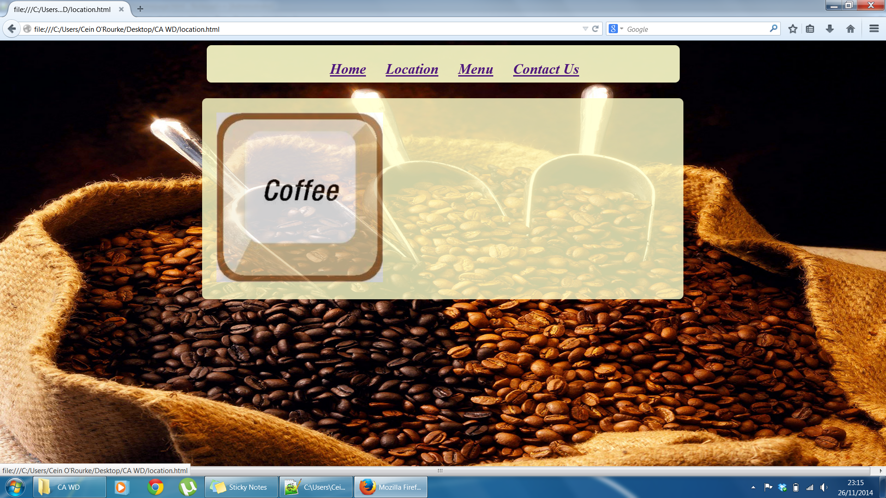

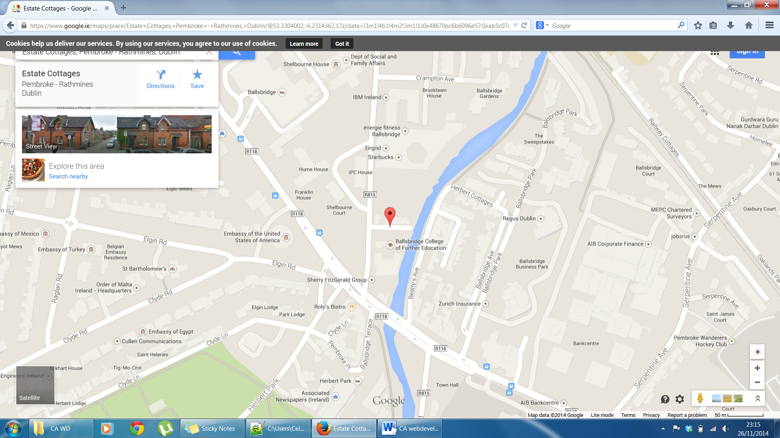

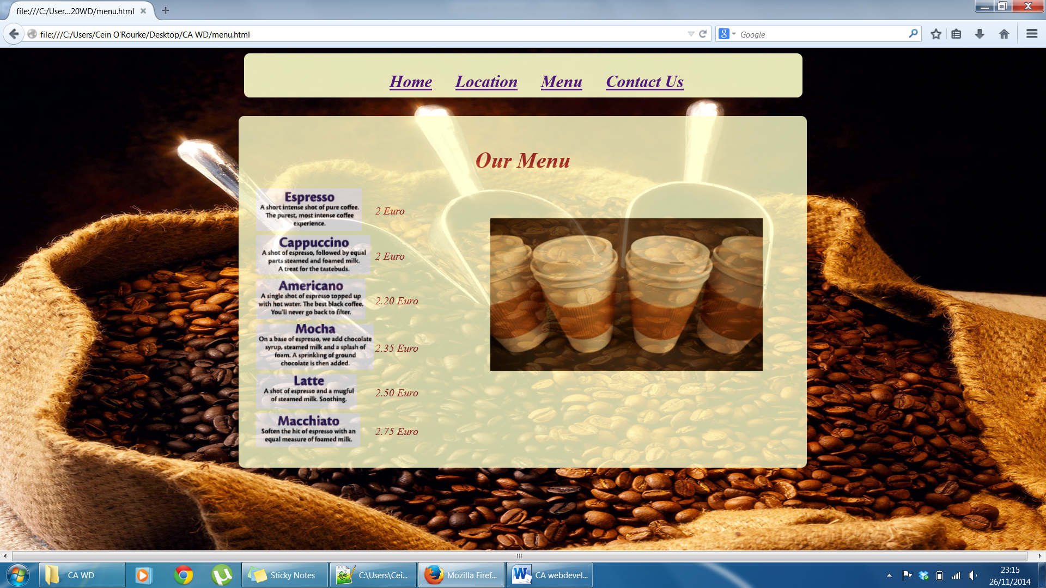

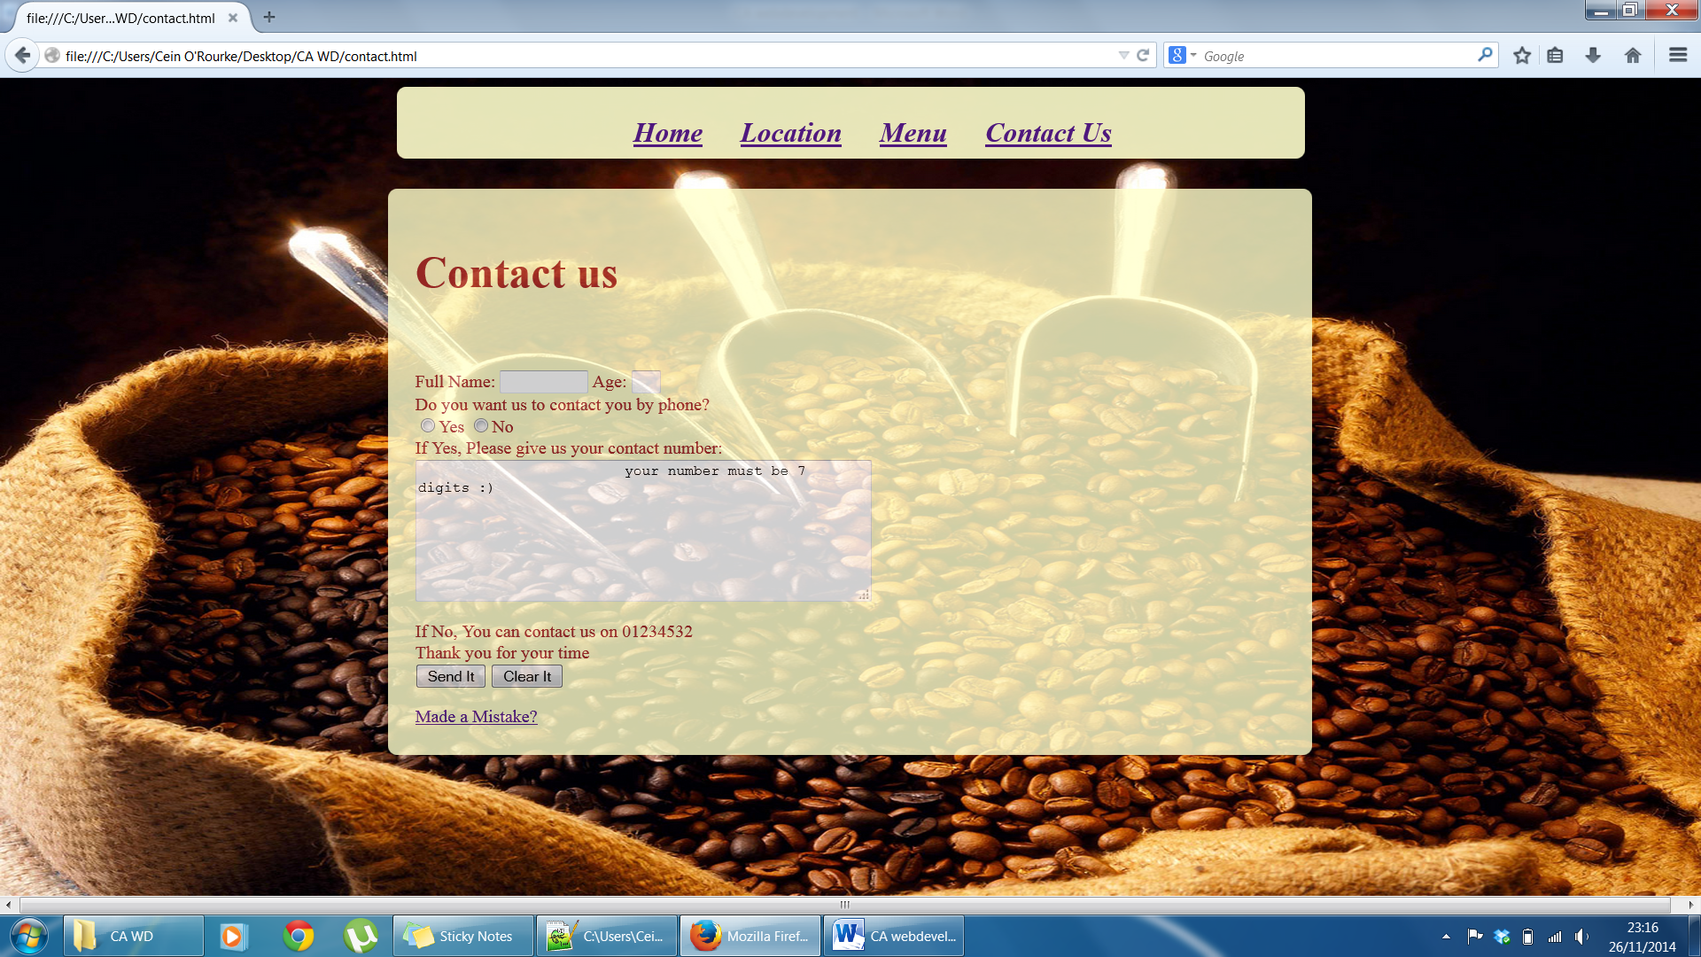

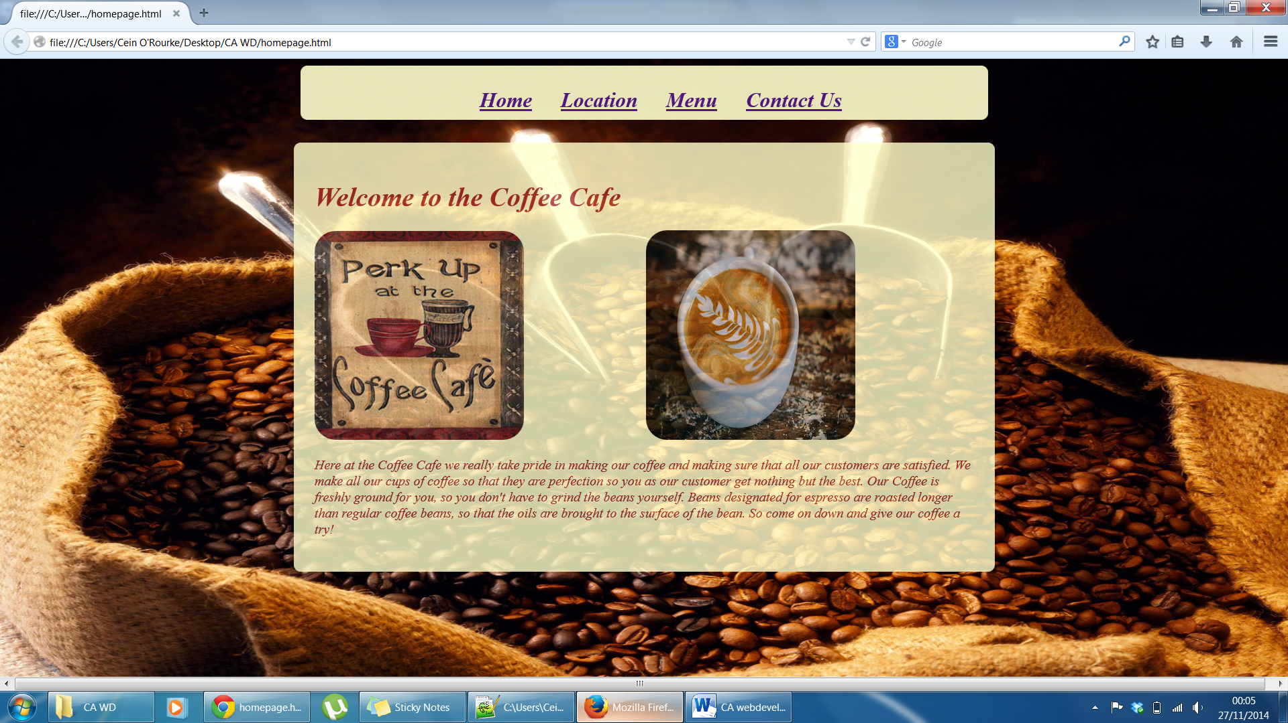

Nielsen’s heuristics

* Visibility of system status

My website is very easily visible and simple for the users visibility

* Match between system and the real world

My website uses simple language and interaction so anybody can use it without complication

* User control and freedom

If the user makes a mistake when giving details it gives the option to start over

* Consistency and standards

My website is very consistent and users will not have to wonder whether a page is different from the other

* Error prevention

My website gives the option to clear the form when a mistake is entered to prevent wrong details being sent in

* Recognition rather than recall

The user can browse the site simply and easily without having to remember information and can easily access a certain page again

* Flexibility and efficiency of use

My website is basic so helps speed up the interaction between the user and my website

* Aesthetic and minimalist design

All my information on my website is relevant to the user and has no irrelevant text or comments

* Help users recognize, diagnose, and recover from errors

I have a mistake link at the end of my contact page so there is no reason for mistakes

* Help and documentation

The user should not need help as my website is so basic

